DATABBASE DESIGN REPORT

Database Design and Normalization

The database design process was carried out by properly analyzing the hospital desired request. The information needed to be stored in the database were Patients, Doctors, MedicalRecords, Appointments and Departments. The main objective was to ensure a normalized database structure was achieved to the Third Normal Form (3NF).

Patients Table:

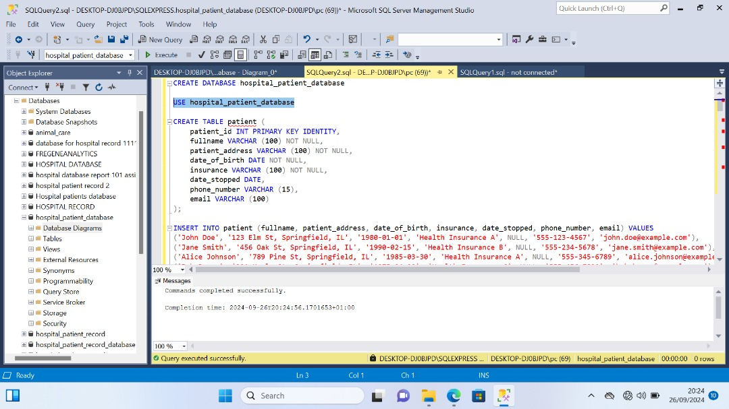

* Colums: patient(Primary Key), fullname, patient_address date_of_birth, insurance, date_stopped, phone_number, email .
* Assumption: To accommodate patients leaving the hospital, a ‘date_stopped’ column was included, and patients leaving dates are recorded.

departments Table:

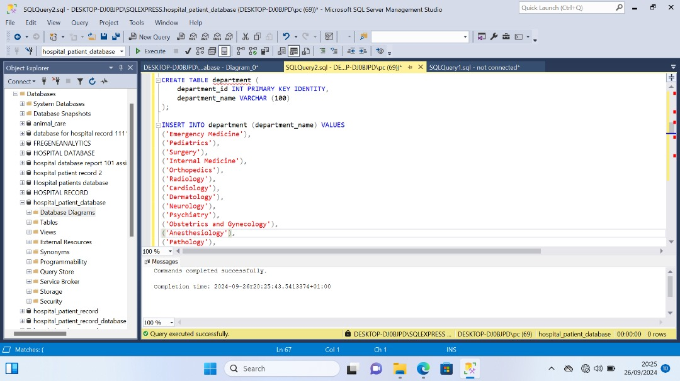

Column: department_id(Primary Key), department_name

doctors Table:

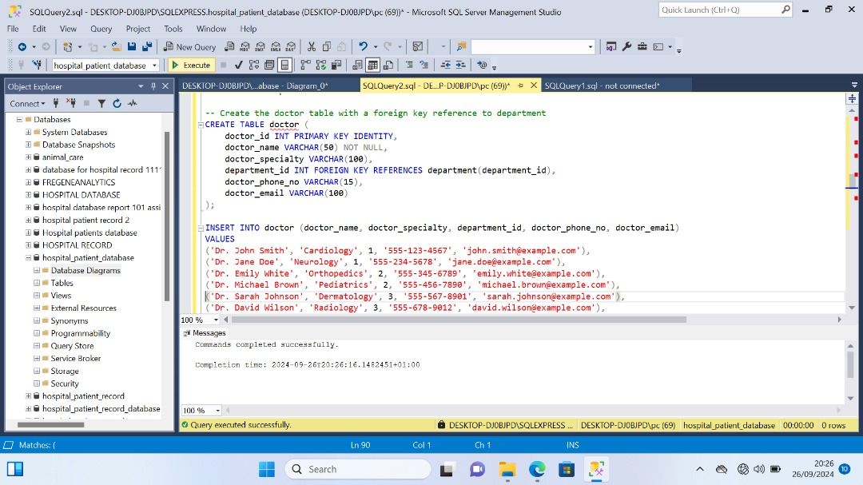

Columns: doctor_id (Primary Key), doctor_name, doctor_specialty, department_id (Foreign Key), doctor_phone_no, doctor_email.

medical_records Table:

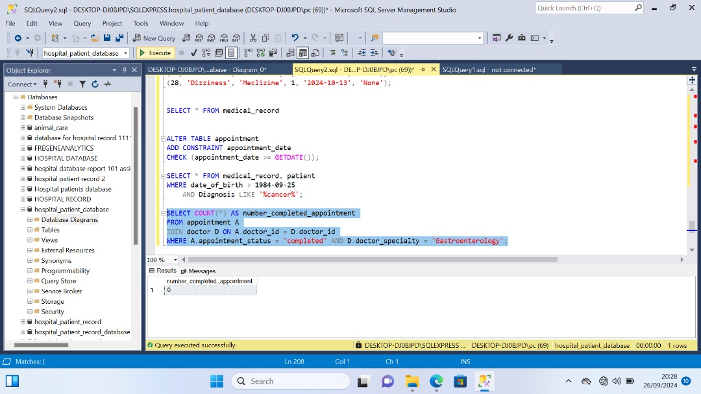

Columns: medical_id (Primary Key), patient_id (Foreign Key), doctor_id (Foreign Key), last_appointment, diagnosis, medicine, allergies.

appointments Table:

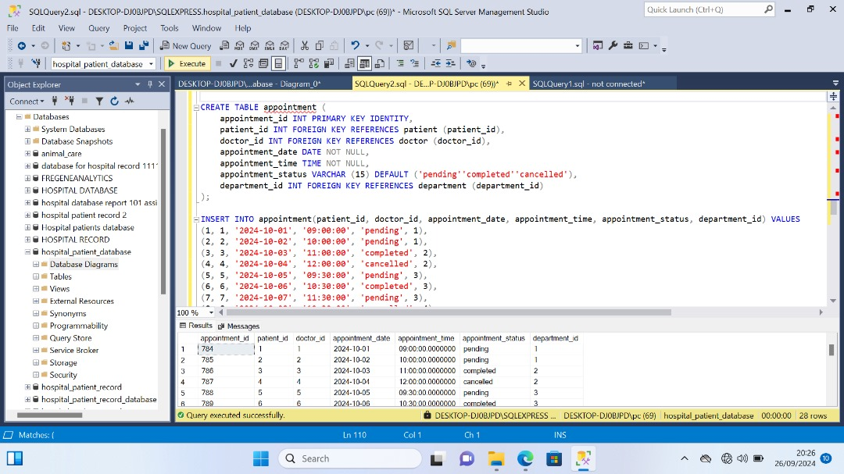

Columns: appointment_id (Primary Key), patient_id (Foreign Key), doctor_id (Foreign Key), department_id (Foreign Key), appointment_date, appointment_time, appointment_status.

Schema Diagram:

This diagram is vital to view each table and how they relate with each other

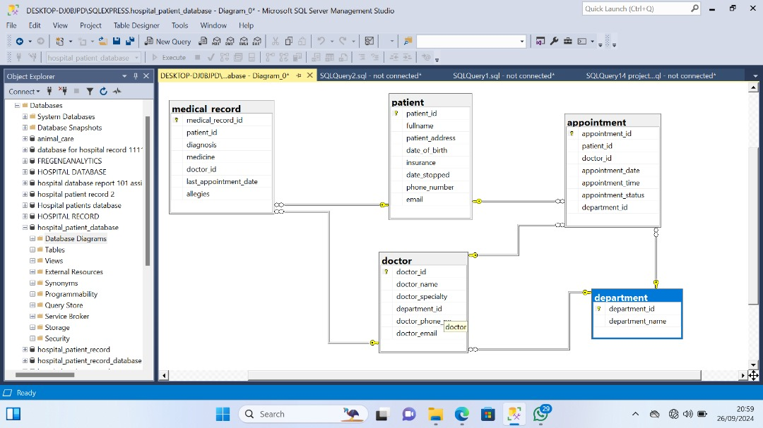

Normalization and Constraints

* The design was meticulously normalized to 3NF, minimizing redundancy while maintaining data integrity.
* Primary and foreign key constraints were implemented to establish robust relationships between tables.

Populating Tables:

* Mock samples were generated and inserted into the tables to facilitate meticulous testing.
* Each of the tables were populated with at least 9 records to ensure the fuctionality and effectiveness of the database

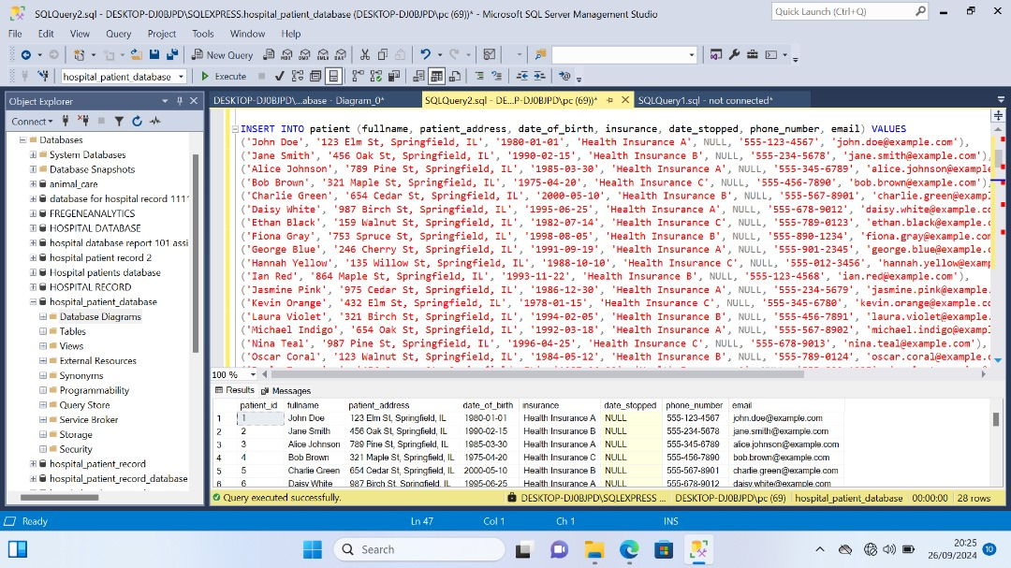

Constraints:

For data integrity, an appointment constraint was implemented to ensure that the appointment date is never set in the past. For appointments in the past, an update statement was used to make sure they tallied with future date appointments.

